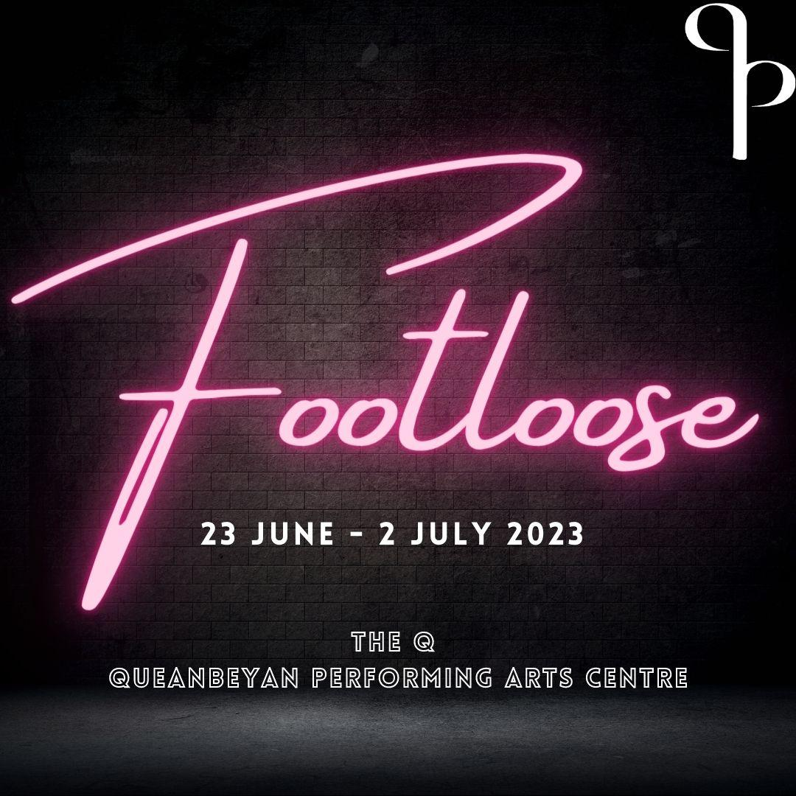

Casting Brief:
Queanbeyan Players is casting for Footloose! Footloose is the story of Ren McCormack, a teenage boy from Chicago. He and his mother move to the small town of Bomont after his father abandons them. Upon arriving, Ren finds himself at odds with most of the town, including the Reverend Bomont. The Reverend has convinced the town to outlaw dancing, which Ren finds unbelievable. With the help of the Ariel (the Reverend’s daughter) and Willard (a country hick who becomes his best friend), Ren convinces the Reverend to let the teenagers dance, and in the process helps the town to heal from a tragedy that affected them all.
This classic movie-turned-musical is sure to win your heart and get your toes tapping.
To be considered for a role in Footloose please book your audition at https://queanbeyanplayers.com/auditions/
If you have any questions regarding anything outlined in the pack, please don’t hesitate to contact auditions@queanbeyanplayers.com

ROLES/CHARACTERS
Ren McCormack - Vocal Range: D3 - C5 - Age range: 16 – 23
Ren is a teenage boy from Chicago who moves to the small town of Bomont with his mother Ethel. Throughout his journey from boyhood to maturity, he forms many friendships with his peers, as well as a romantic relationship with the female lead Ariel. Any actor who plays Ren must be able to sing, dance and act, and be able to play a witty joker who enjoys a good time.
Ariel Moore - Vocal Range: G3 – Eb5 - Age range: 16 - 23
Ariel is the daughter of Reverend Moore and Vi, and is dealing with the grief of losing her brother. She has a romantic relationship with Chuck at the start of the show but later becomes interested in Ren. Ariel is smart, and she understands the rules of the different worlds she moves between. When she’s in her father’s presence, she is buttoned-up and demure, while with Chuck, she burns off all her unexpressed, explosive energy with thrill-seeking behaviour. Any actress who plays Ariel not only has to be able to sing, act and dance, but she also needs to be able to portray a rebellious and confident teen with an unseen emotional side in which she shares with Ren.
Rusty - Vocal Range: A3 – F#6 - Age range: 16 – 23
Rusty’s character comes across as very sassy and self-assured. Any actress who plays Rusty must be a very strong singer and must also be able to portray her deeply romantic character, for she truly believes that she and Willard are meant to be together despite their differences.
Willard Hewitt - Vocal Range: Bb2 – Ab4 - Age range: 16 – 23
Willard is a gentle soul with quick fists, which are his defence against the world that he often has trouble comprehending. The humour in the character of Willard derives from his gradual innocent and giddy discovery of the new worlds that his budding friendship with Ren, and his romantic connection with Rusty opens up to him. The actor who plays Willard must be able to provide the comedic relief while being able to sing, act and not only dance badly, but also dance well.
Reverend Shaw Moore - Vocal Range: A2 – F#4 - Age range: 30+
The secret to the character of Reverend Moore is that he is charismatic and charming. Shaw has a quick mind, a loving heart and a sense of humour, all of which endear him to his congregation. While trying to be strong for so many people, he continues to mourn the death of his son – the one person he could not save. Any actor playing this character must be able to sing and act, as well as portray the glimpse of frustration and temper that arises from his grief and private anguish.
Urleen - Vocal Range: A3 – D5 - Age range: 16 – 23
Urleen is one of Ariel’s friends from school in the town of Bomont. Any actress who plays this character must be able to sing and harmonise very well, as well as act and dance.
Wendy Jo - Vocal Range: A3 – E5 - Age range: 16 – 23
Wendy Jo is also one of Ariel’s friends from school in the town of Bomont. Any actress who plays this character must be able to sing and harmonise very well, as well as act and dance.
Chuck Cranston - Vocal Range: F#3 – B4 - Age range: 16 – 25
Chuck is Ariel’s boyfriend and local bad boy in Bomont. Any actor playing Chuck must be able to sing, dance, and act as well as portray his rebellious and unpredictable character.

Vi Moore - Vocal Range: A3 – Db5 - Age range: 30+
Vi is Shaw’s wife and the keeper of the Moore household. Despite the loss of her son and the strained relationship with her husband, Vi fully understands what kind of unflagging good humour she must display in order to keep her household – and her husband’s congregation – running smoothly. Any actress playing Vi must be able to sing and act well.
Ethel McCormack - Vocal Range: A3 – D5 - Age range: 30+
Much like her son Ren, Ethel is intelligent, resilient, and has a great sense of humour. Since her divorce, she feels like she needs to be strong for Ren. Their mutual loss has brought them closer together and they share a teasing, good-natured relationship. Any actress playing Ethel must be able to sing and act well.
Cowboy Bob - Vocal Range: E3 – C5 - Age range: 25 – 35
Cowboy Bob is a fun and upbeat character with great charm and charisma. Any actor playing this character must be able to sing, dance, and act well.
Ensemble
The ensemble is a critical part of this show and will appear in various forms throughout. Strong singers are required. As Footloose is a pretty dance heavy musical, all ensemble members will need to be able to move comfortably and confidently in character.
Production Schedule:
18 June - Bump In
19 June – Tech Rehearsal
20 June – Dress Rehearsal
21 June – Dress Rehearsal
22 June – Dress Rehearsal/Potential Preview
23 June – OPENING NIGHT – 7:30PM
24 June – 2PM & 7:30PM
25 June – 2PM
28 June – 7:30PM
29 June – 7:30PM
30 June – 7:30PM
1 July – 2PM & 7:30PM
2 July – CLOSING SHOW 2PM
Performances will take place at the The Q – Queanbeyan Performing Arts Centre, located at 253 Crawford St, Queanbeyan.
Audition Dates: Saturday 14th January from 9:30AM, Sunday 15th from 9:30AM
Call-backs (if required) Monday 16th from 7PM
Venue: Queanbeyan Uniting Church, Rutledge St Queanbeyan

Audition Requirements
ACTING/SINGING
Copies of the readings will be available on the day.
Please bring sheet music for the accompanist or a backing track (we will have a bluetooth speaker available) for your audition. Singing acapella is not acceptable.
CHARACTER | SINGING REQUIREMENT | ACTING REQUIREMENT
Ren | Please choose 2 songs from the 80’s, one upbeat and one ballad | page 60-62 from top of scene 7 to “I… hate… you!”
Ariel | Please choose 2 songs from the 80’s, one upbeat and one ballad | page 60-62 from top of scene 7 to “Tell it to the train”
Rusty | Please choose 2 songs from the 80’s, one upbeat and one ballad | page 79-80 from “arrgh!” To “my baby’s in a panic!”
Willard | Please choose 2 songs from the 80’s, one upbeat and one ballad | page 31-33 from Willard “hey mister you bumped me” to Ren “nothing!”
Urleen | Please choose 2 songs from the 80’s, one upbeat and one ballad | Please prepare either Ariel or Rusty’s reading
Wendy Jo | Please choose 2 songs from the 80’s, one upbeat and one ballad | Please prepare either Ariel or Rusty’s reading
Reverend Shaw | Pick a song from the 80’s of your choosing, but take into consideration the character of Shaw | page 105-106 from Ren: “Reverend” to Shaw: “Goodnight Mr McCormack”
Vi | Pick a song from the 80’s of your choosing, but take into consideration the character of Vi | page 46-47 from “shaw if you’re angry with Ariel please tell her why” to “I seem to have walked in on one of your sermons”
Ethel | Pick a song from the 80’s of your choosing, but take into consideration the character of Ethel | page 103-105 from “Ren. Up til now…” to “you have no choice. Now go!”
Chuck | Pick a song from the 80’s of your choosing, but take into consideration the character of Chuck | page 57-58 from “Ariel what the hells going on?” To “Say it again baby”
Cowboy Bob | Pick a song from the 80’s of your choosing. | We may ask you to do a cold read to see further characterisation.
ENSEMBLE | Pick a song from the 80’s of your choosing. | We may ask you to do a cold read to see further characterisation.
Note: The Audition panel may not choose to hear all of your song/s during the audition. This may purely be for time purposes, or they have heard what they require. Please don’t assume this is a bad sign, as this is a quite normal process for many auditions.
CHOREOGRAPHY AUDITION: A 25 minute movement and dance audition will be scheduled in groups, auditionees will be offered the movement audition slot closest to their audition time, or they can pick an alternate dance audition time. Footloose is a dance heavy show. Please arrive warmed up, stretched and in clothes that you are comfortable moving/jumping in (no jeans or high heels). The point of this audition is to see how you move and how you perform. We do not expect you to learn the choreography perfectly but expect that you give you do your best.

IMPORTANT INFORMATION FOR AUDITIONEES
Rehearsals: Every Monday and Thursday 7:30-10:30PM and Sunday 1-5PM commencing 29 January.
Venue: Queanbeyan Uniting Church – early rehearsals may be held elsewhere due to a potential venue conflict, however that will be confirmed and communicated well prior to rehearsals commencing. Current used venues for QP rehearsals are, Gowrie Primary School and Chifley Health and Wellbeing Hub.
Being in a Queanbeyan Players show is both fun and rewarding; however, in order to have a quality production, we do require a certain amount of commitment from cast members. Queanbeyan Players invests significant cost, time and effort to stage a show and to also run the company during the year, therefore we must charge people money for tickets. Because we are charging audience money, we need to provide as high a standard of production as possible as a community theatre company. Please read these notes carefully and decide whether or not you can provide this level of commitment before you audition.
Both in rehearsal & during performances the Director, Musical Director, Choreographer, Production Manager and Stage Manager are in charge and you will be expected to work to their directions. We will be rehearsing on Monday & Thursday evenings from 7.30 to 10.30pm and Sundays 1 – 5pm in Queanbeyan. You may not be called for every rehearsal, or for the whole time, but you must attend every rehearsal for which you are called. We cannot halt rehearsals over school & public holidays (except Easter/Christmas). If you know you will be unavailable on these or any other dates, please let the Director know at auditions. (We will not consider you ineligible for the cast, but we do need to know absences so that rehearsals can be structured accordingly.)
Cast members will be required to read our relevant policies and sign a code of conduct. Our aim at Queanbeyan Players is for everyone to have fun when doing a QP production, and provide a welcoming and safe environment.
If you are unable to comply with the above commitments, you may be asked to leave the cast.
There may be additional all-day rehearsals closer to the performance dates. Bump in will be on Sunday 18th June 2023. Performances will be from 23rd June – 2nd July 2023. Attendance at rehearsals during Production week and at performances is mandatory.
A full-length stage production is fairly demanding, both in time and effort. It can be both physically and mentally stressful. If you have a medical condition which you think we may need to know about, we would urge you to have a confidential word with the Director, who will then know if they should be taking this condition into account before asking you to do something which may not be comfortable for you.
If you are accepted into the cast, you must become a financial member of The Queanbeyan Players Inc. This is primarily related to insurance purposes. The Membership Secretary will be present at the first read-through/rehearsal to accept membership dues. Information about the cost of this and any additional costs will be sent to you if you are accepted into the cast.
We run our shows on a very small budget. We are therefore unable to provide such items as shoes or make-up for cast members. You will be provided with costumes, and we are always happy to see people who can either make their own costume or can find someone to sew it for them! You may be required to help make and/or paint scenery, and to help move the sets in and erect them at bump-in.
Please note that Queanbeyan Players Inc. pursues an alcohol-free policy during both rehearsals and performances.
You will be informed whether or not you are successful in the auditions by email or phone call as soon as possible after we finish auditions & call-backs. If you do not hear from us before the first rehearsal, please contact Janette at auditions@queanbeyanplayers.com . Good luck with your audition!
COVID-19 Safe Plan
Queanbeyan Players is registered as a COVID-19 safe company and all COVID safe plans must be adhered to by everyone. Everyone must sign in and out every time you enter or exit the building we are using. There will be hand sanitiser in every room for your use. If you are feeling unwell then please let us know before you arrive for your audition and we will do our best to reschedule your audition or find an alternative method. Bring your own water bottle.

Please fill out and bring the audition form on the next page to your audition.

QUEANBEYAN PLAYERS INC.
AUDITION FOR: “Footloose: The Musical”

NAME: _______________________________________________ AGE: _______ (if under 18)
MY PRONOUNS ARE: ____________________________(such as he/she/they, optional)
ADDRESS: ________________________________________________________________
PHONE –HOME: __________________ MBL: ______________________
E-MAIL: ___________________________________________________________________
VOCAL TRAINING (where, when): ______________________________________________________
DRAMATIC TRAINING (where, when): __________________________________________________
DANCE TRAINING (where, when): ______________________________________________________
THEATRICAL EXPERIENCE (use back of form): ____________________________________
IF YOU PLAY ANY MUSICAL INSTRUMENT/S NOTE WHICH ONE/S AND LEVEL OF PROFICIENCY ATTAINED: ___________________________________________________
___________________________________________________________________________
VOICE (tick): • Soprano • Mezzo-Soprano • Alto
• Tenor • Baritone • Bass • Don’t know

VOCAL RANGE (if known):______________________________________

AUDITIONING FOR (tick – you may nominate more than one category):
• Principal/Supporting Role (specify) _______________________________
• Ensemble (Please tick ‘ensemble’ if you are willing to be an ensemble member if not selected for a principal role)
• Pit Singer (There may be the opportunity to pit sing in this production, please tick if you would like to be considered)
If not cast as a performer, are you prepared to participate in another capacity?
• No • Yes (specify) ___________________________________________________
(eg. Orchestra, wardrobe, set construction and painting, front-of-house, backstage crew, publicity)
Do you have any commitments that would conflict with rehearsal and production dates?
• No • Yes (specify) ___________________________________________________
I acknowledge that I have read, understood and agree to accept the conditions and responsibilities described in the ‘Important Information for Auditionees for Queanbeyan Players Inc’.
SIGNATURE: ____________________________________________ DATE: ______________
(If auditionee is under 18, this form must be signed by a parent or guardian)

